**PRACTICAL 1**

**AIM:-**Install Selenium IDE; Write a test suite containing minimum 4 test cases for different formats

**STEPS to install Selenium IDE:**

**Step1:**

Launch Chrome Browser.

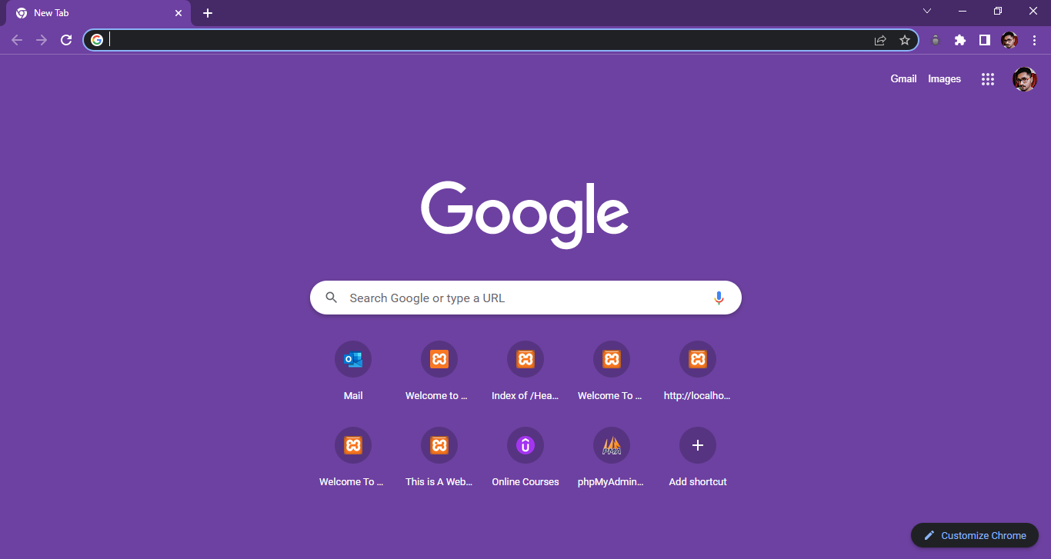

**Step2:**

Type URL <https://www.seleniumhq.org/download/>

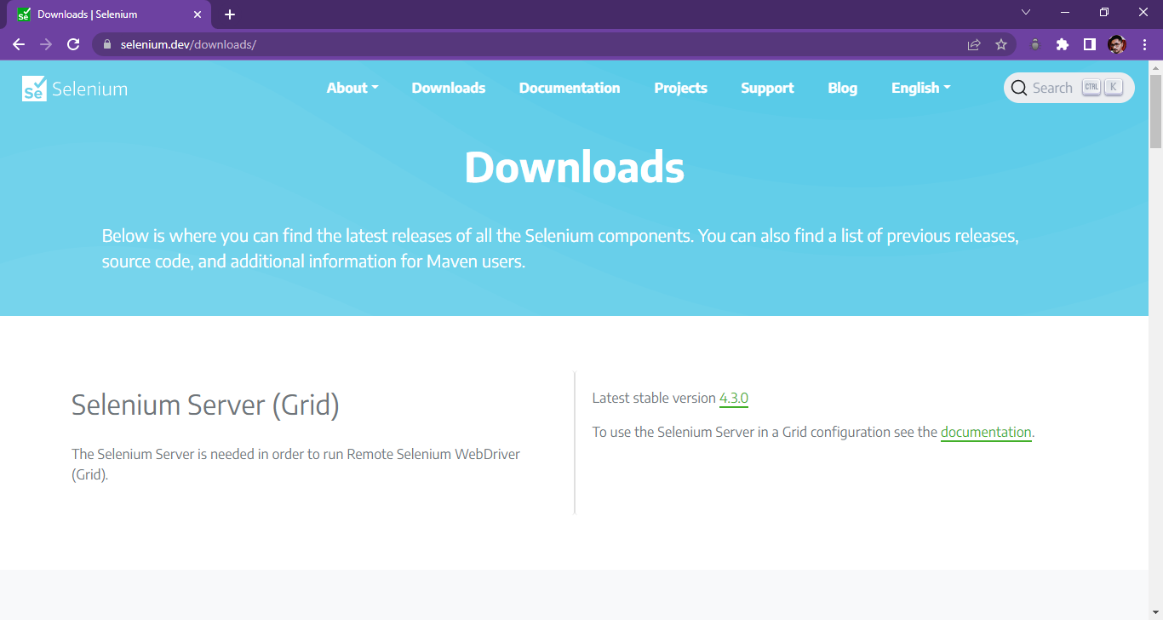

**Step3:**

Scroll Down to Selenium IDE, and download the latest released version for Chrome.

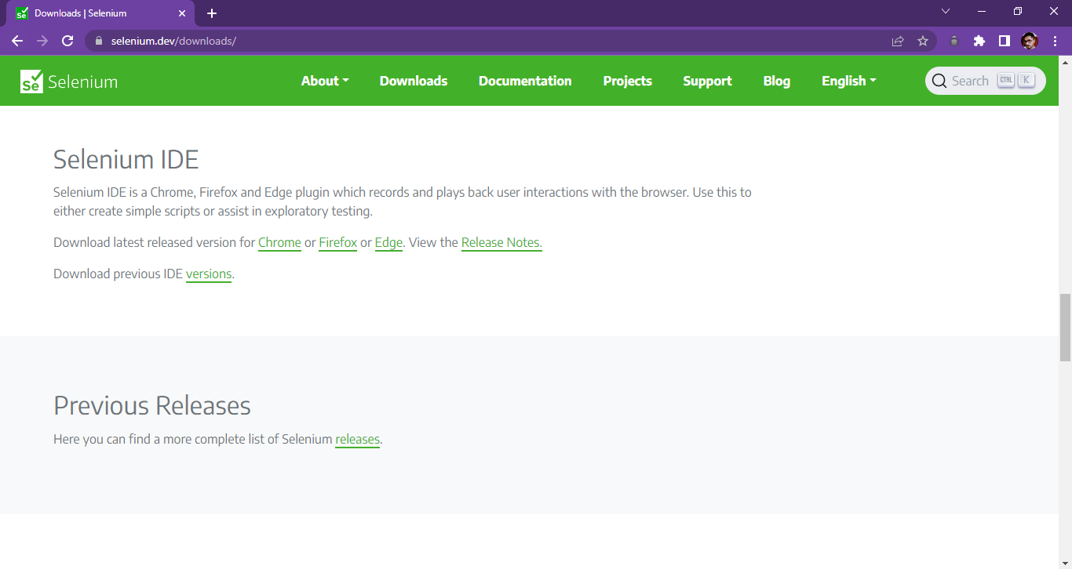

**Step4:**

It will redirect to a page similar to this. Click on Add to Chrome.

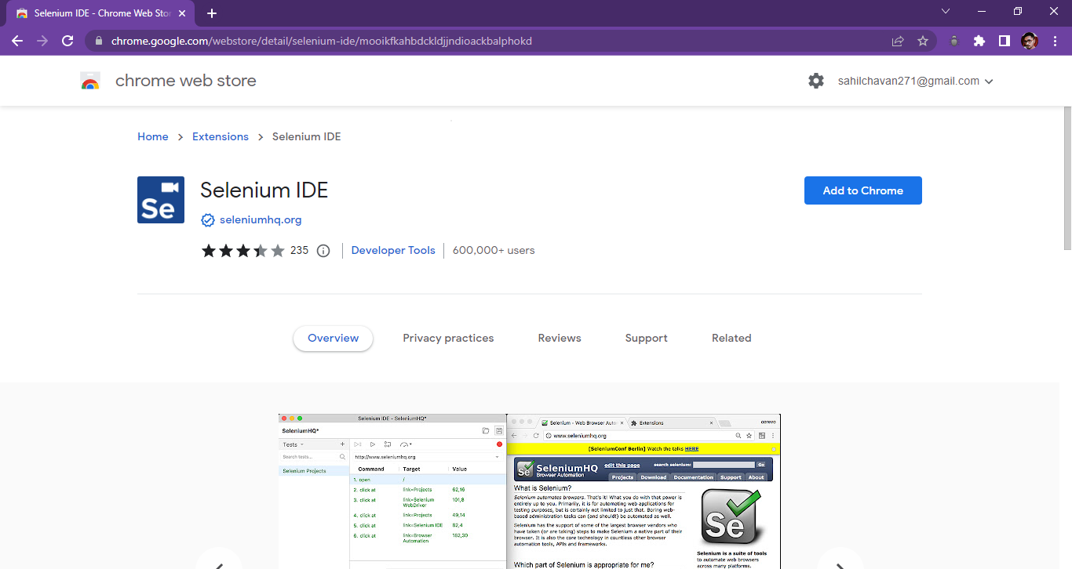

**Step5:**

Chrome will show one popup saying do you want to allow Chrome to install Selenium IDE Add-ons or not. Click to add extension.

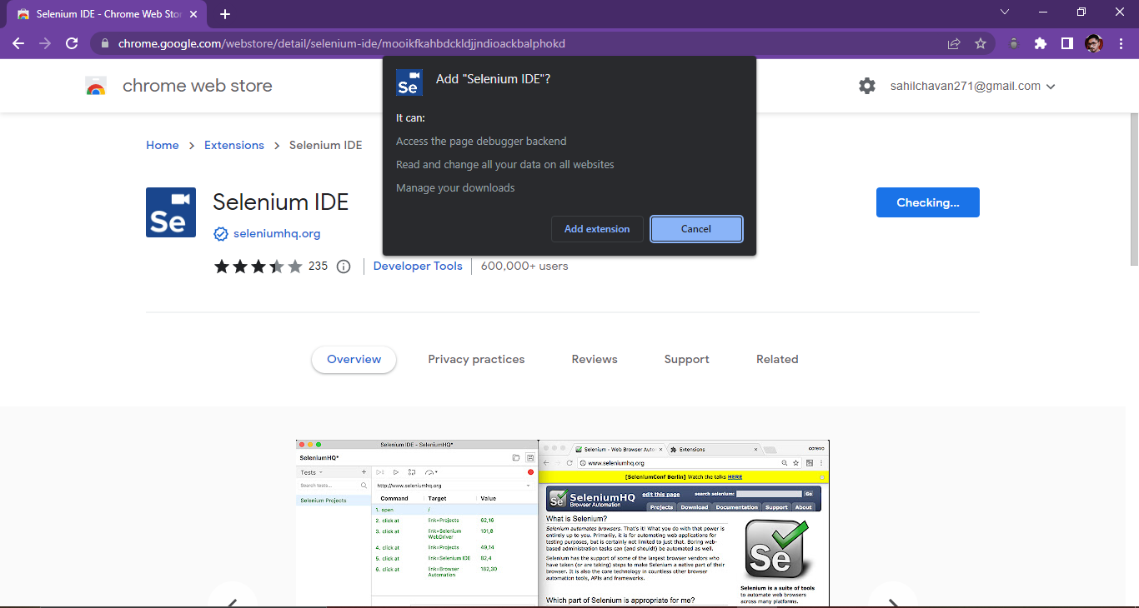

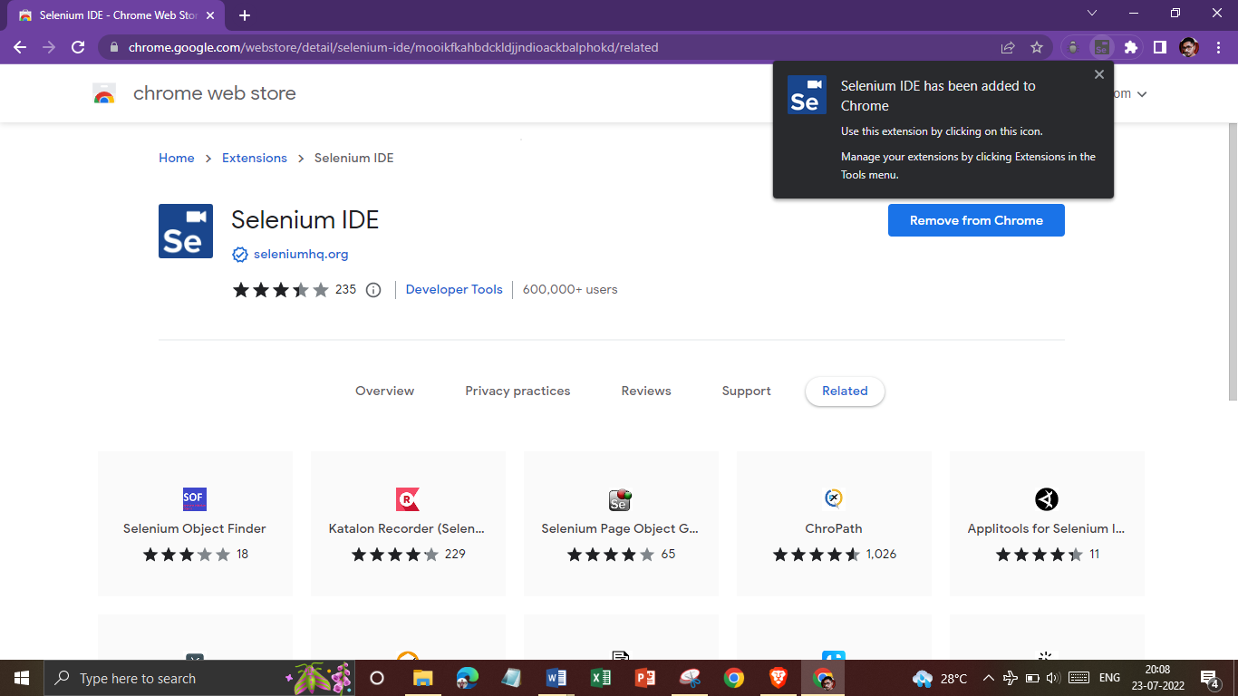

**Step6:**

We can see selenium IDE under the tools menu list. Selenium IDEiconwill be displayed in the Chrome toolbar.

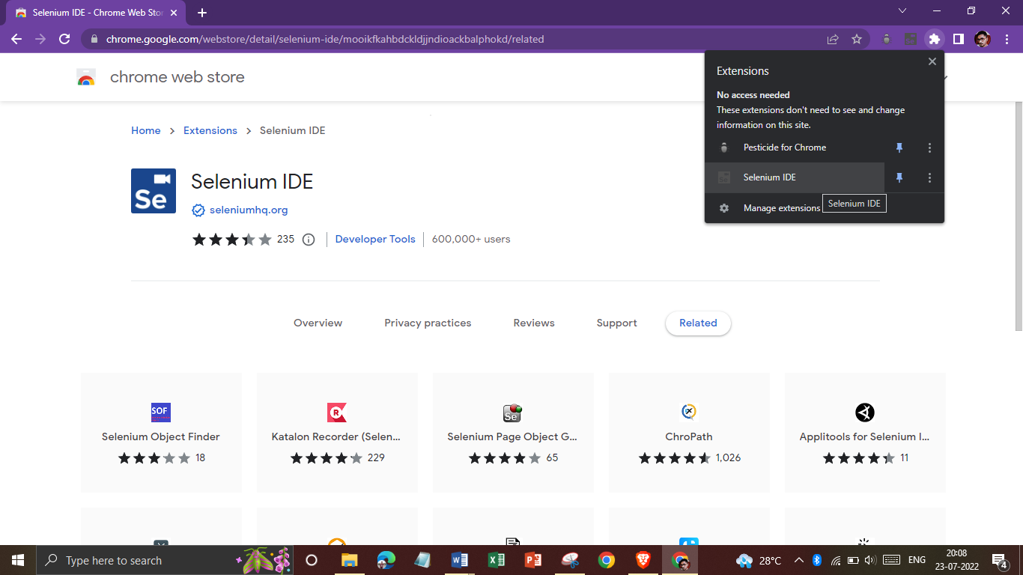

**Step7:**

Click on Selenium IDE icon to open Selenium IDE.

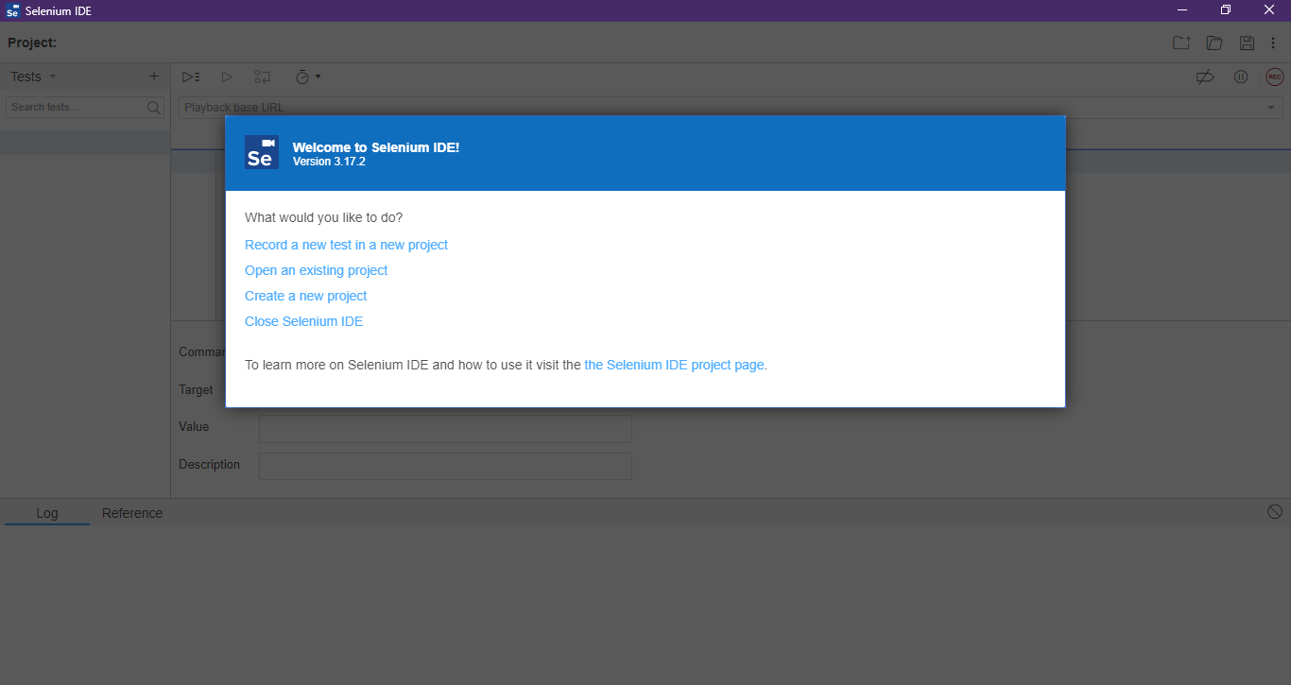

**Test Cases:**

**I) demo.guru99**

**Step 1:**

Launch Chrome and Selenium IDE.

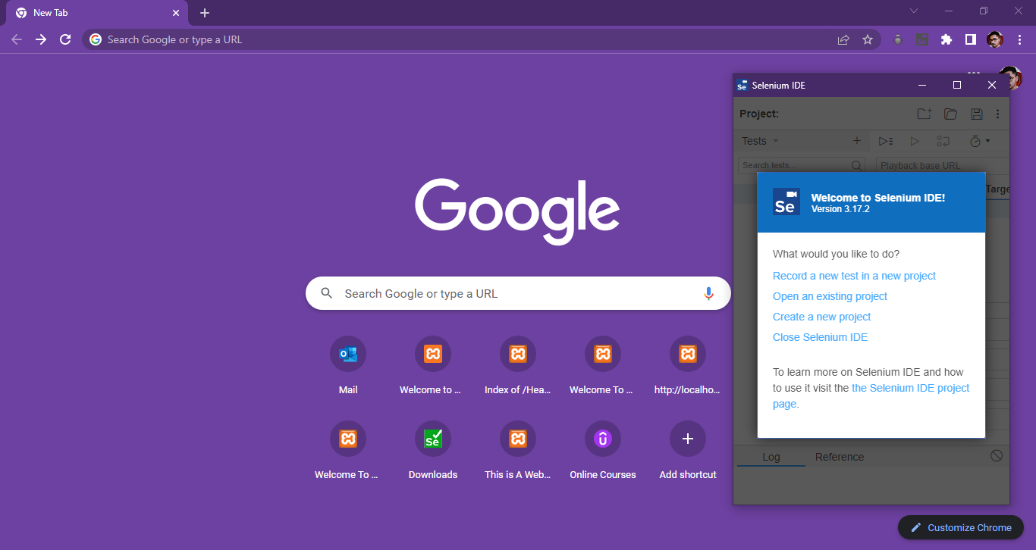

**Step 2:**

Click on “Create a new project”, and name it as follows:

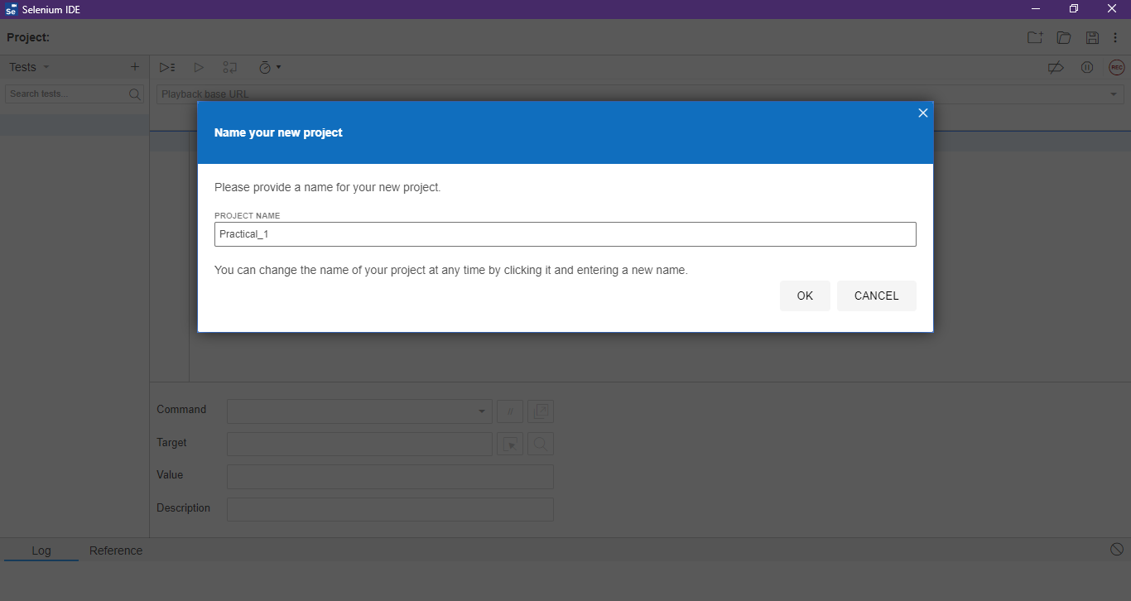

**Step 3:**

Type the value for our Base URL: <http://demo.guru99.com/test/newtours/>, and then toggle the Record button on.

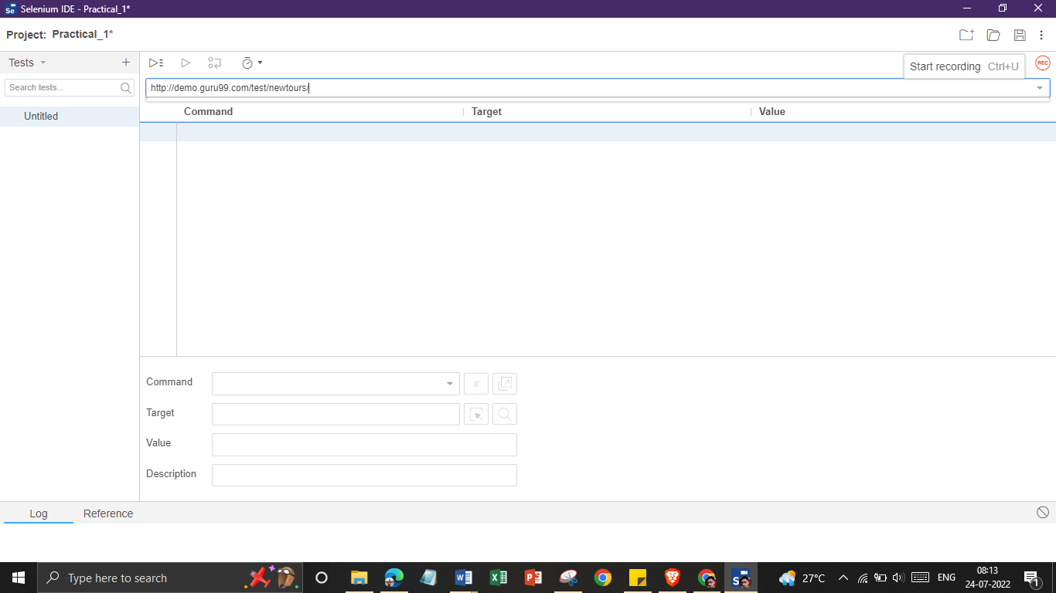

**Step 4:**

Chrome should take you to the page similar to the one shown below.

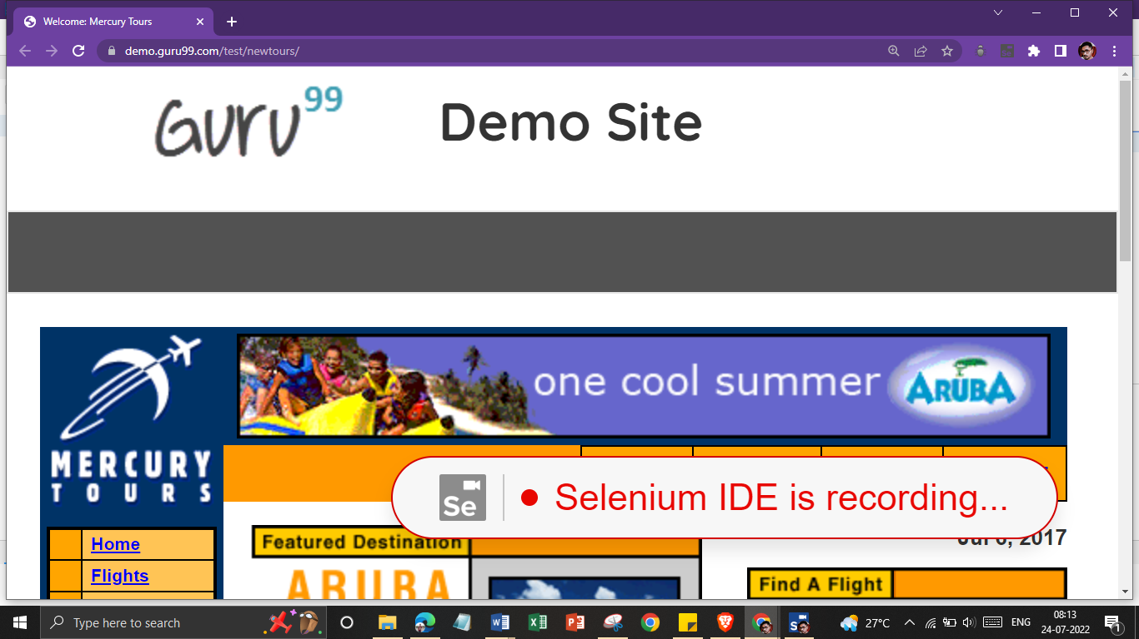

**Step 5:**

Right-click on any blank space within the page, this will bring up the Selenium IDE context menu. Select “assertTitle”. This is a command that makes sure that the page title is correct. 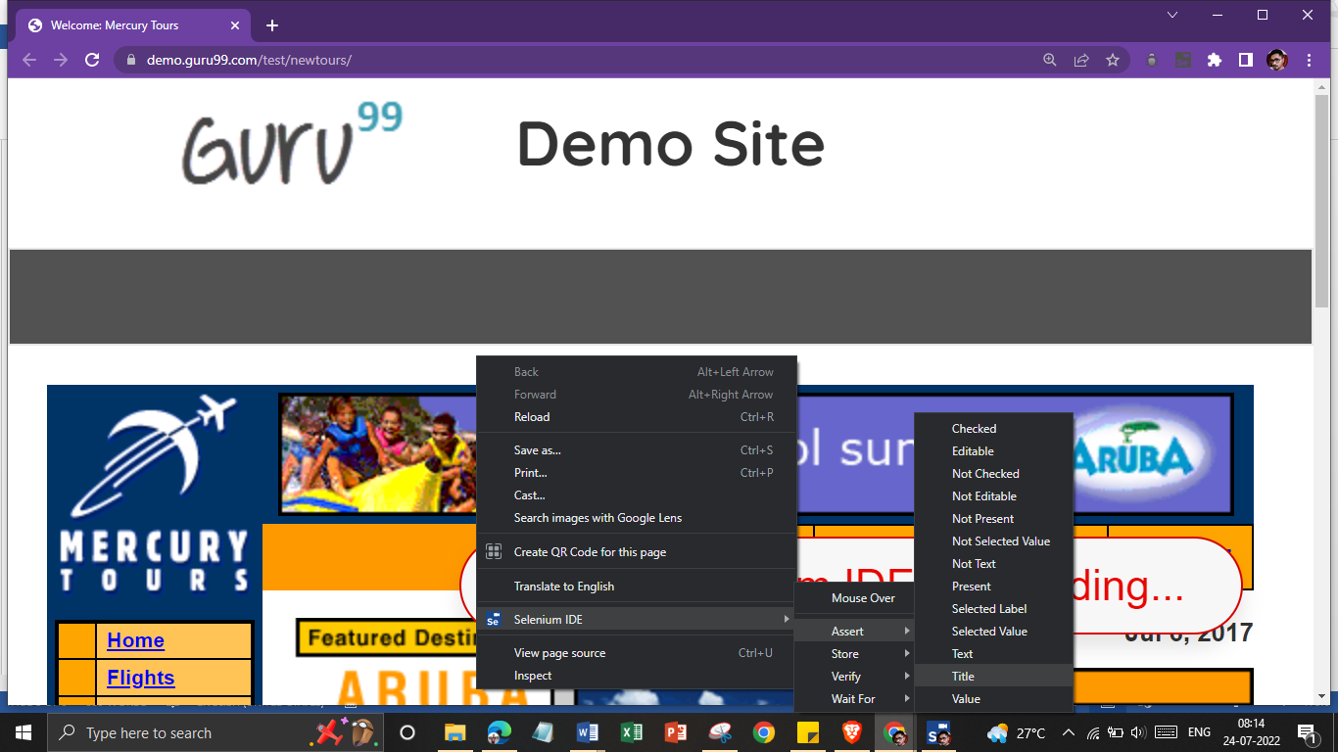

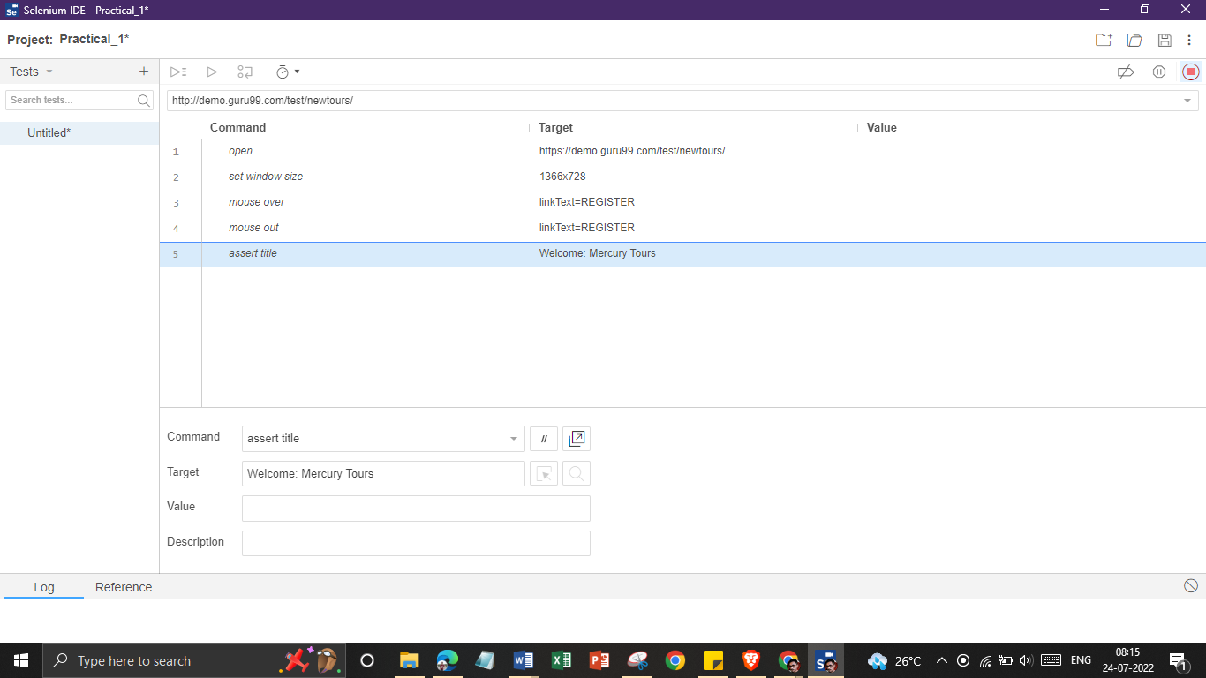

**Step 6:**

In the “User Name” and “Password” text box of Mercury Tours, type an invalid username, "invalidUNN", and an invalid password, "invalidPWD".

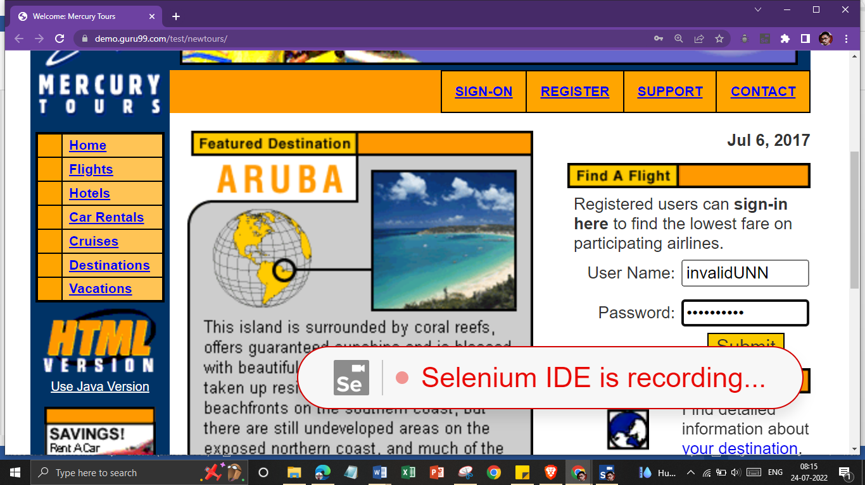

**Step 7:**

Click on the “Sign-In” button. Chrome should take you to this page.

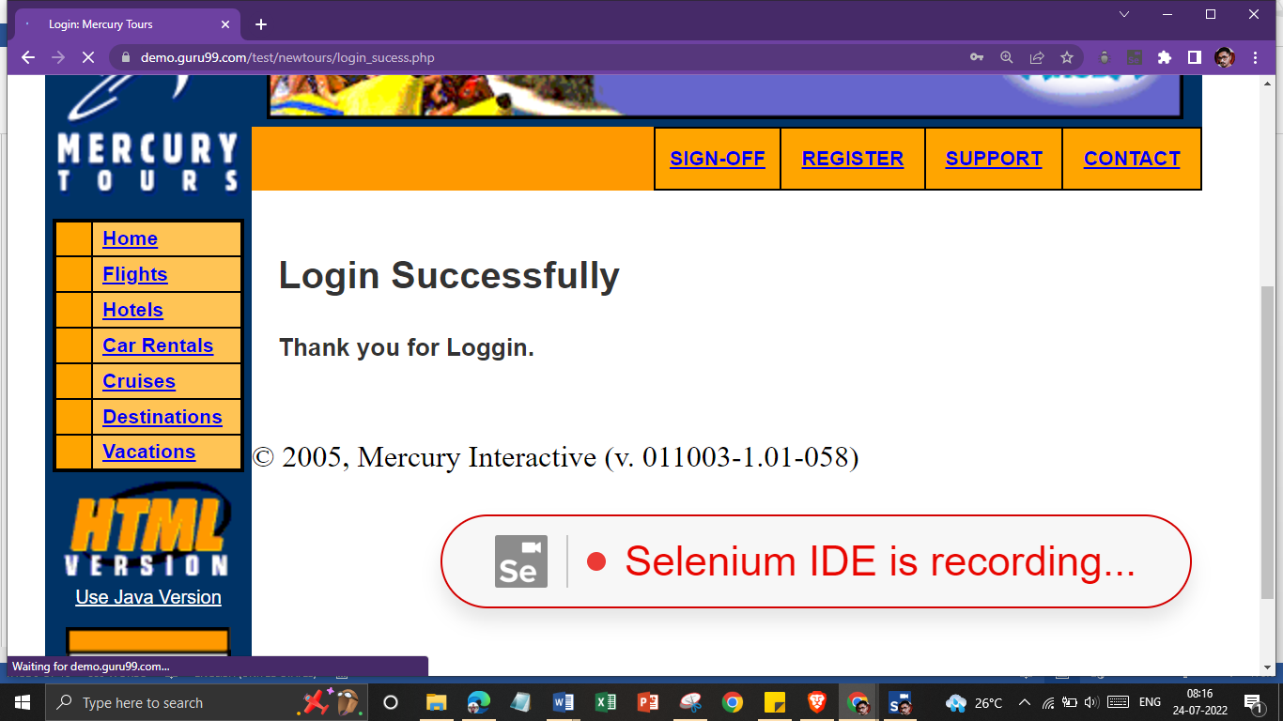

**Step 8:**

Toggle the record button off to stop recording.

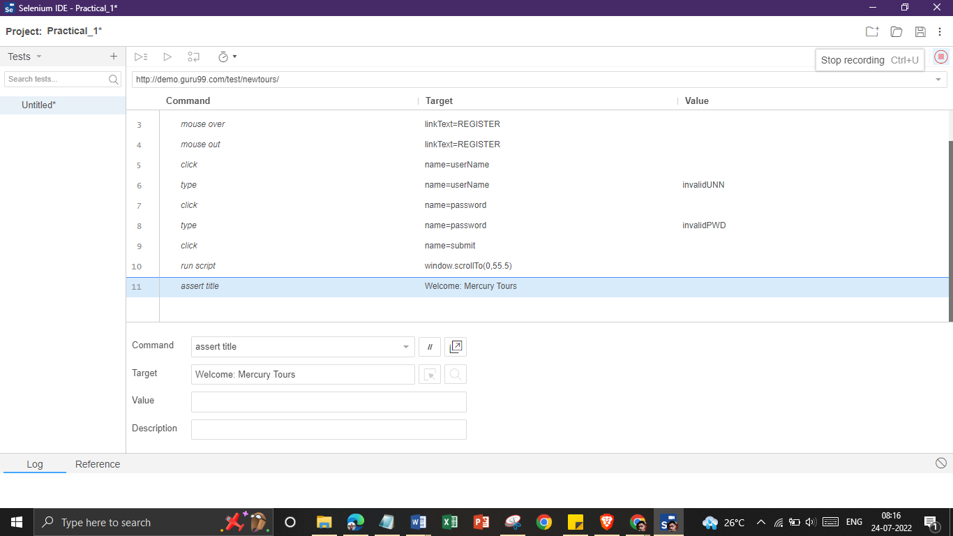

**Step 9:**

Now that we are done with our test script, we shall save it in a test case.

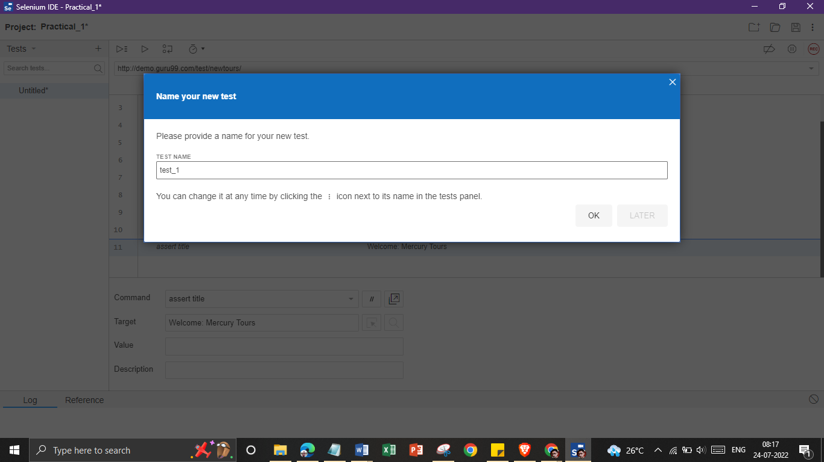

**Step 10:**

Choose your desired location, and then Click the "Save" button.

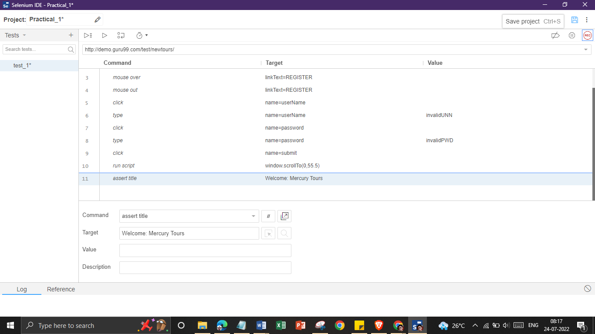

**Step 11:**

Notice that the file was saved as side extension.

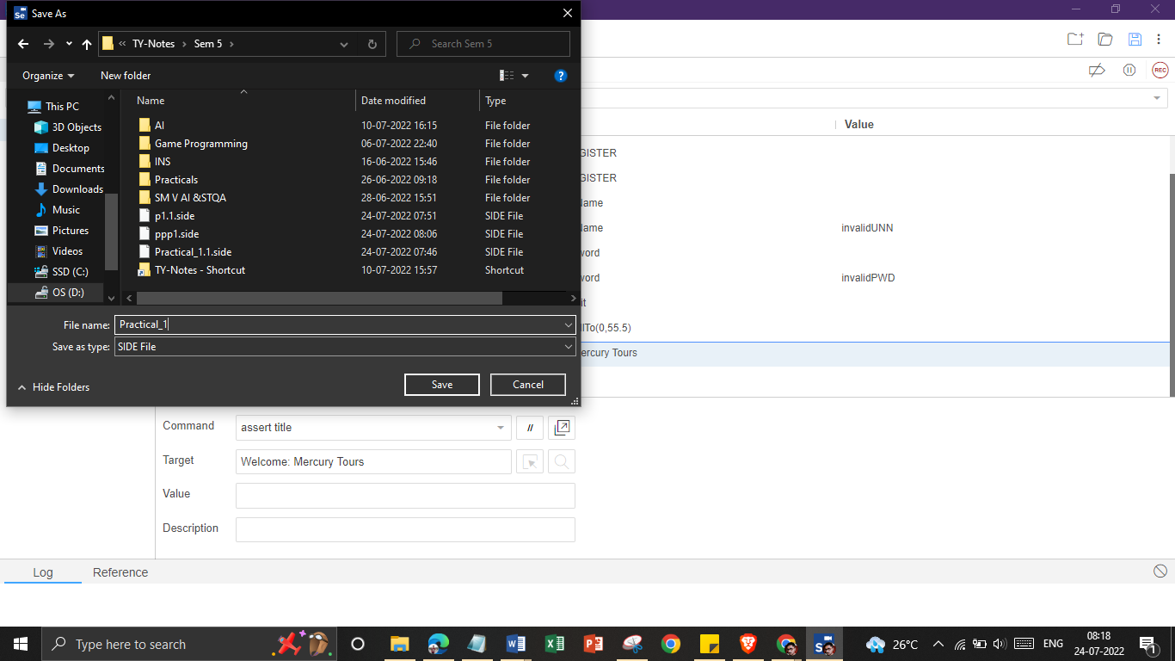

**Step 12:**

Go back to Selenium IDE and click the Playback button to execute the whole script. Selenium IDE should be able to replicate everything properly.

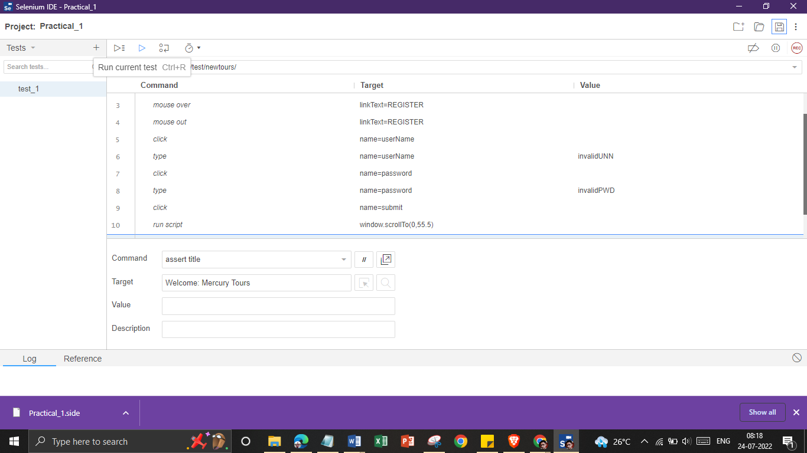

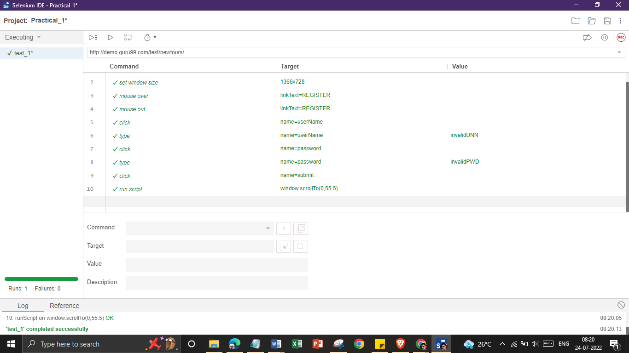

**II) For google.com:**

**Step 1:**

Click on “+” icon to add a new test case and name it as follows:

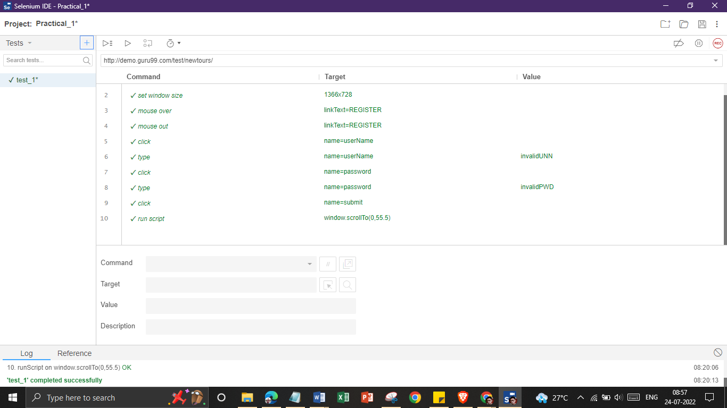

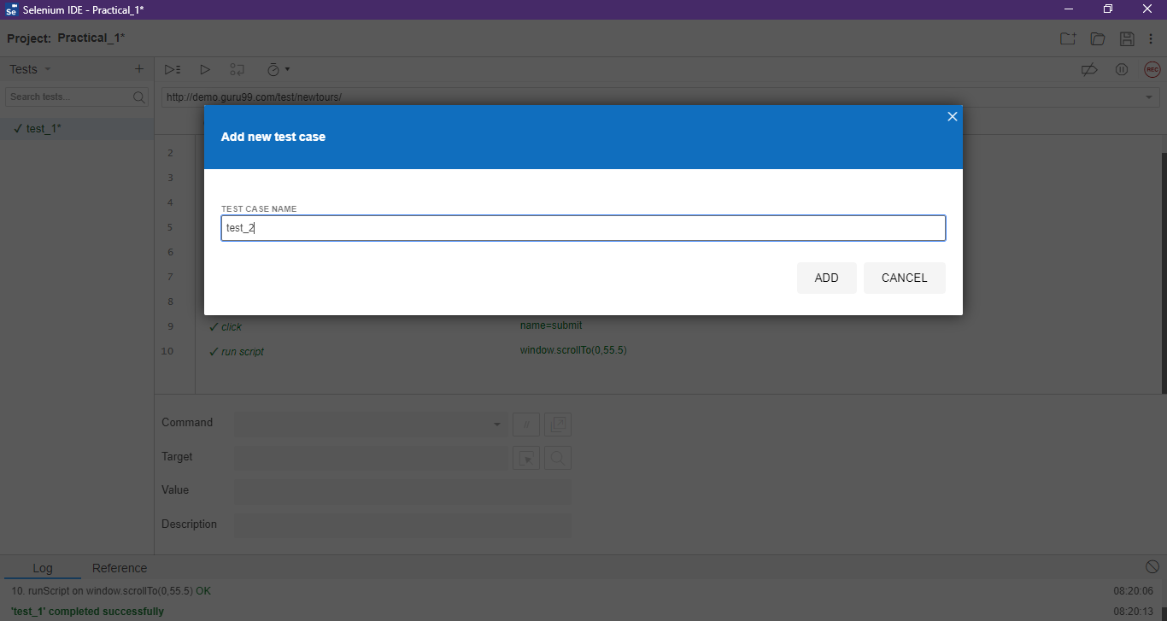

**Step 2:**

Enter the base URL <https://www.google.com> and click on Record Button.

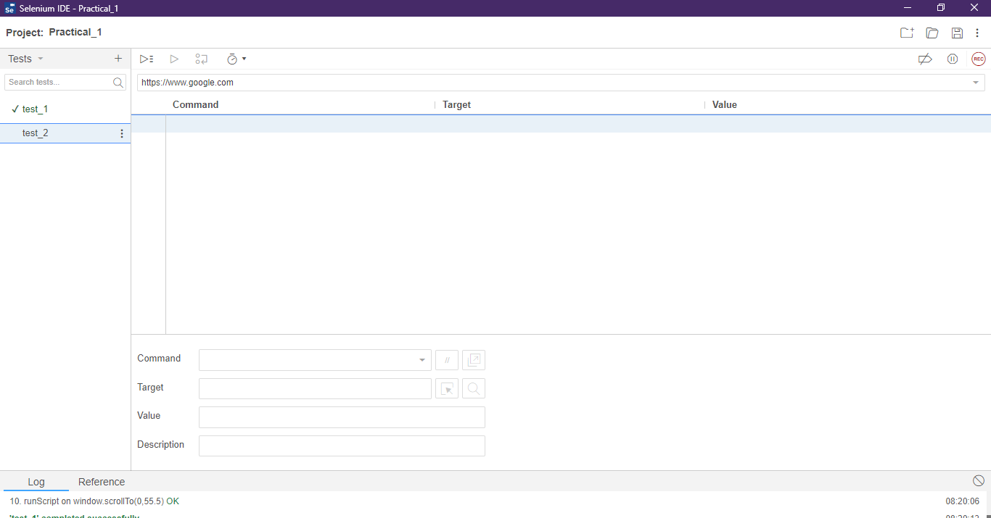

**Step 3:**

Chrome will open the Google Page as follows:

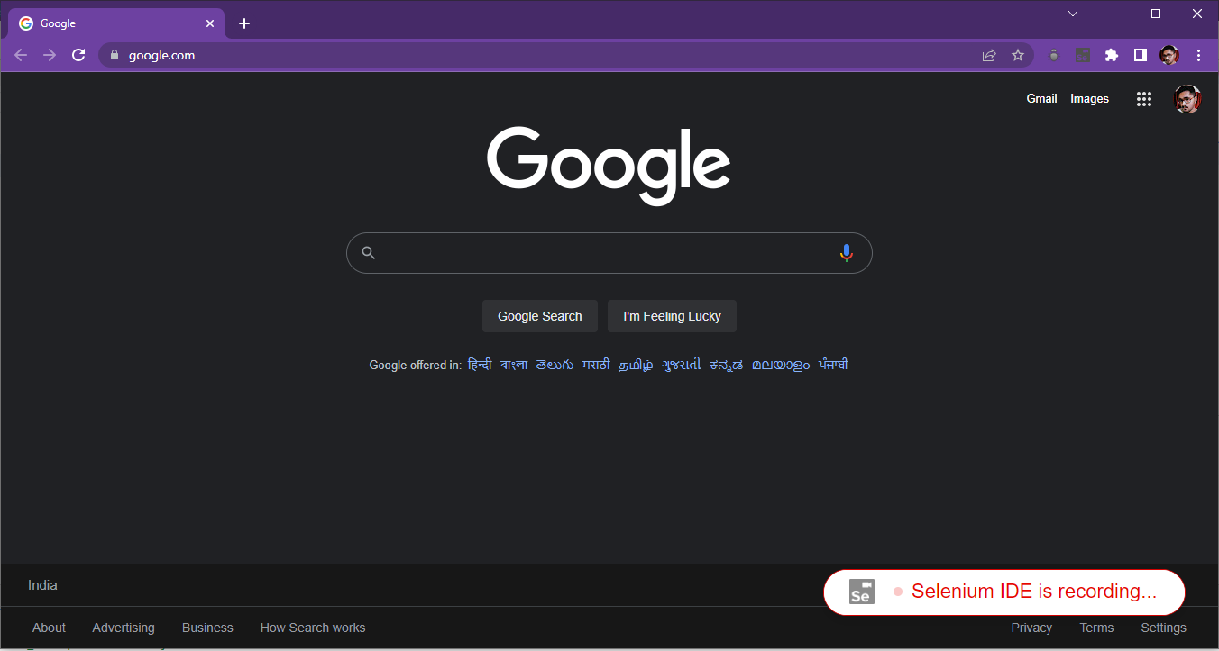

**Step 4:**

Perform The Following Steps:

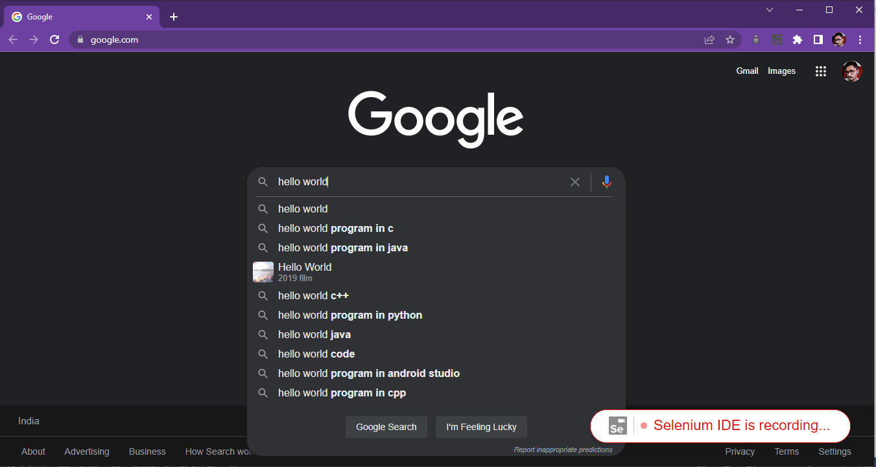

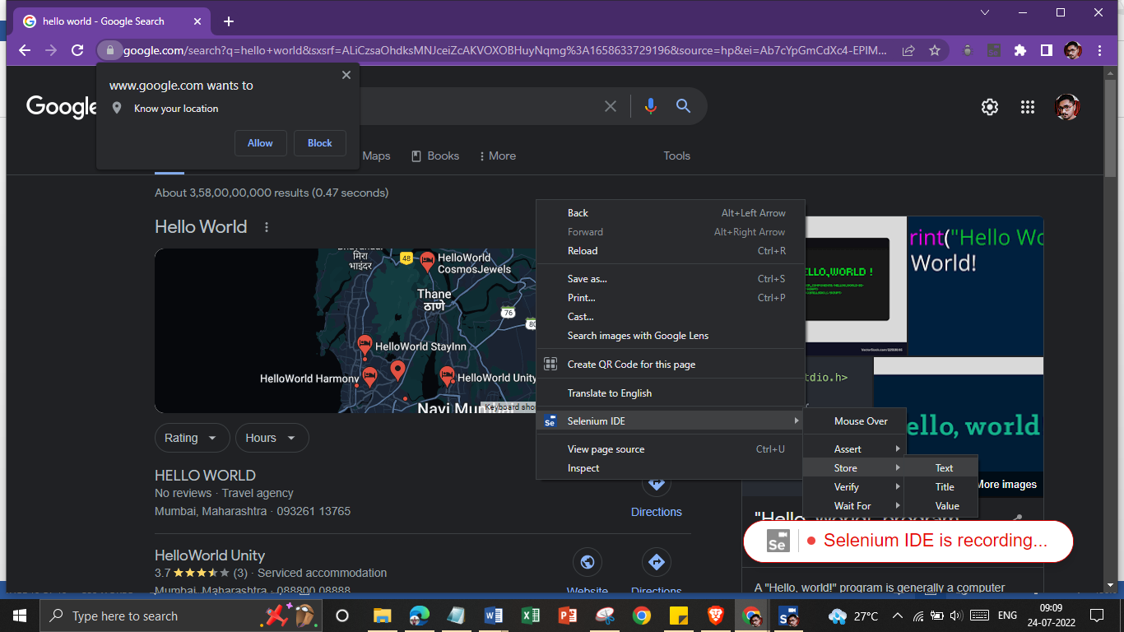

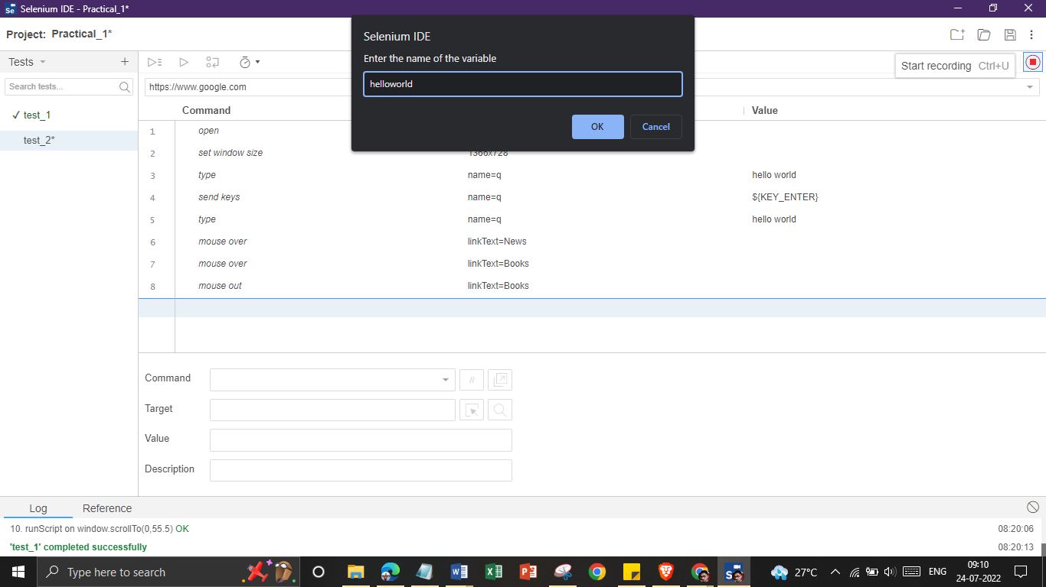

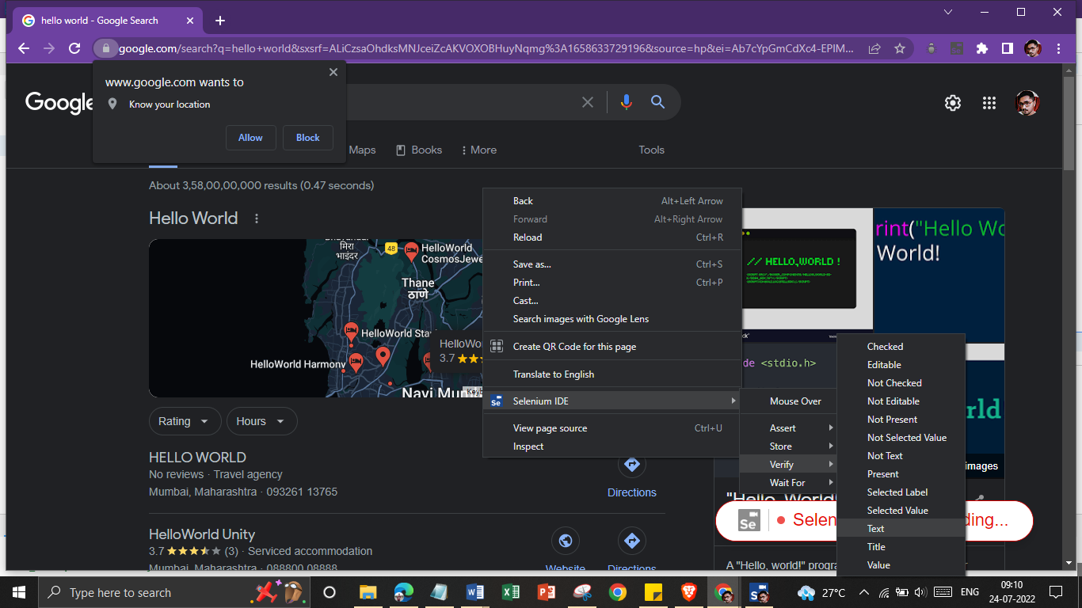

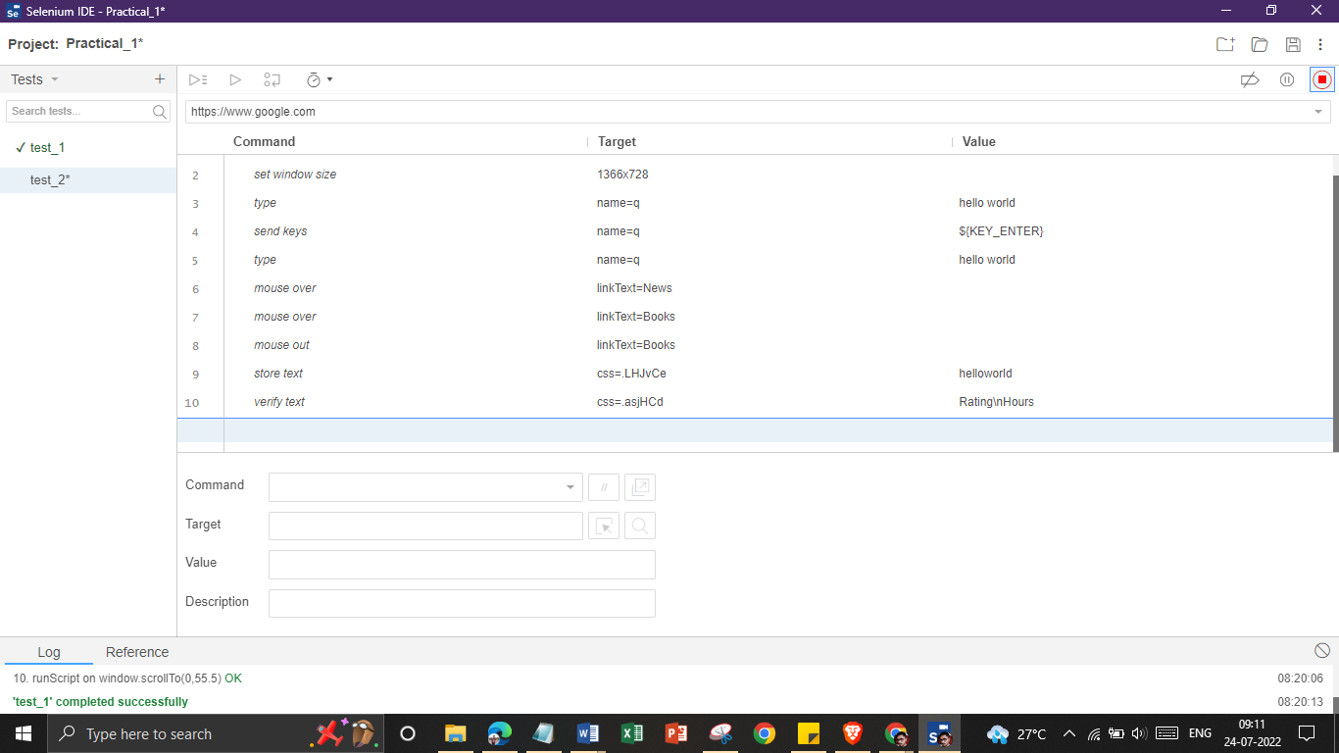

**Step 5:**

Save the Test and Click on “Run Current Test”.

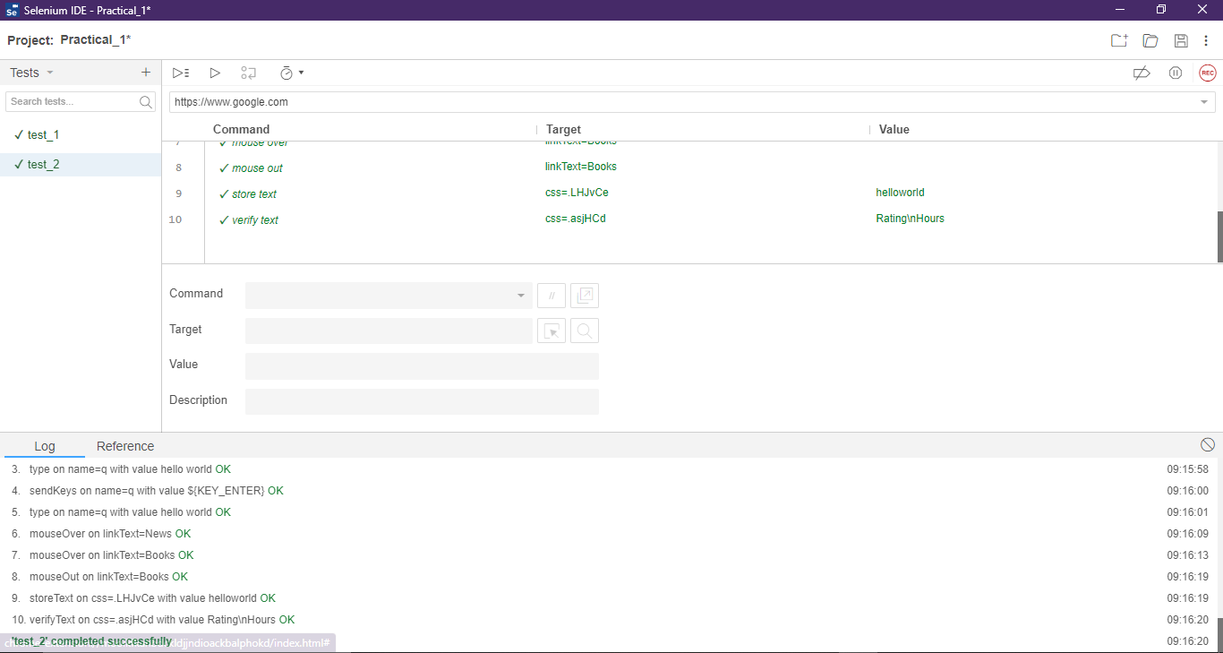

**III) For yahoo.com:**

**Step 1:**

Click on “+” icon to add a new test case and name it as follows:

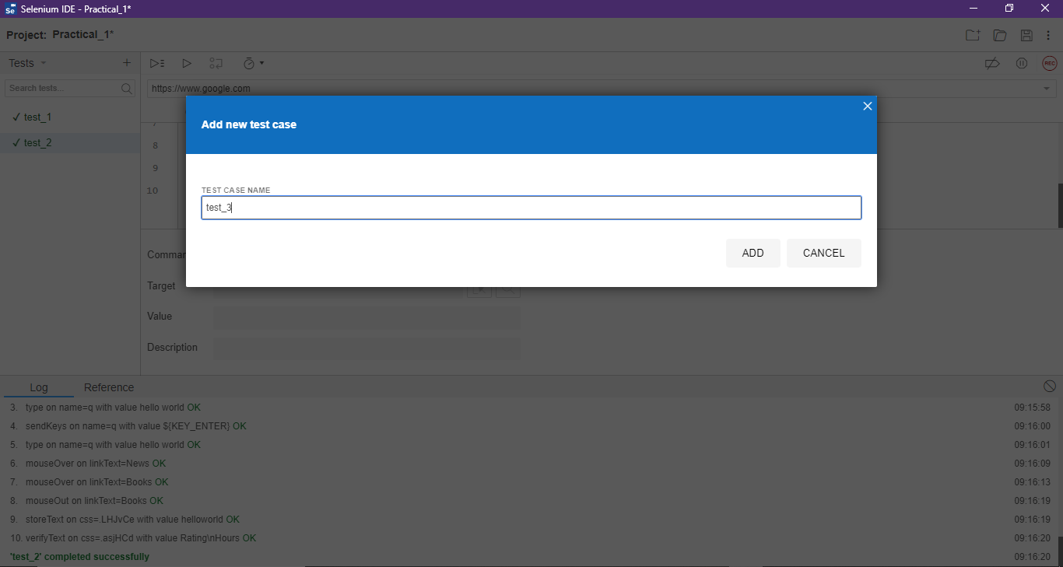

**Step 2:**

Enter the base URL <https://www.yahoo.com> and click on Record Button.

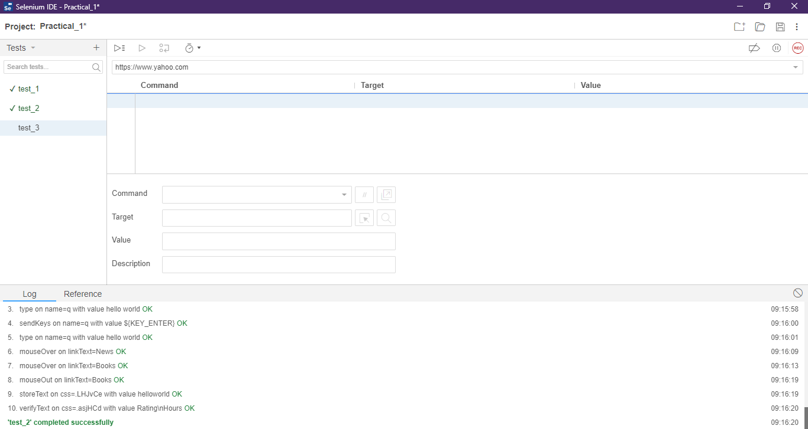

**Step 3:**

Chrome will open the Yahoo Page as follows:

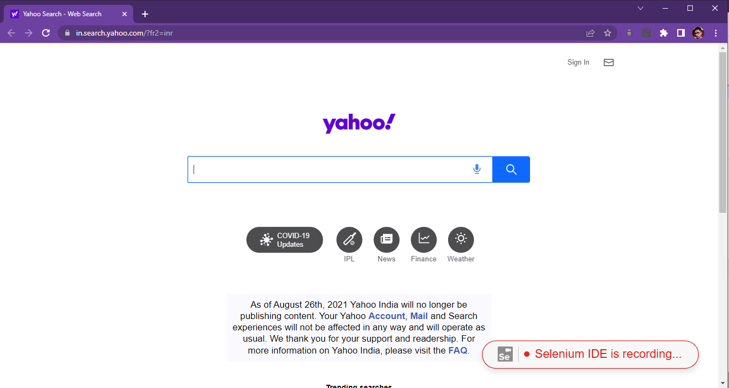

**Step 4:**

Perform The Following Steps:

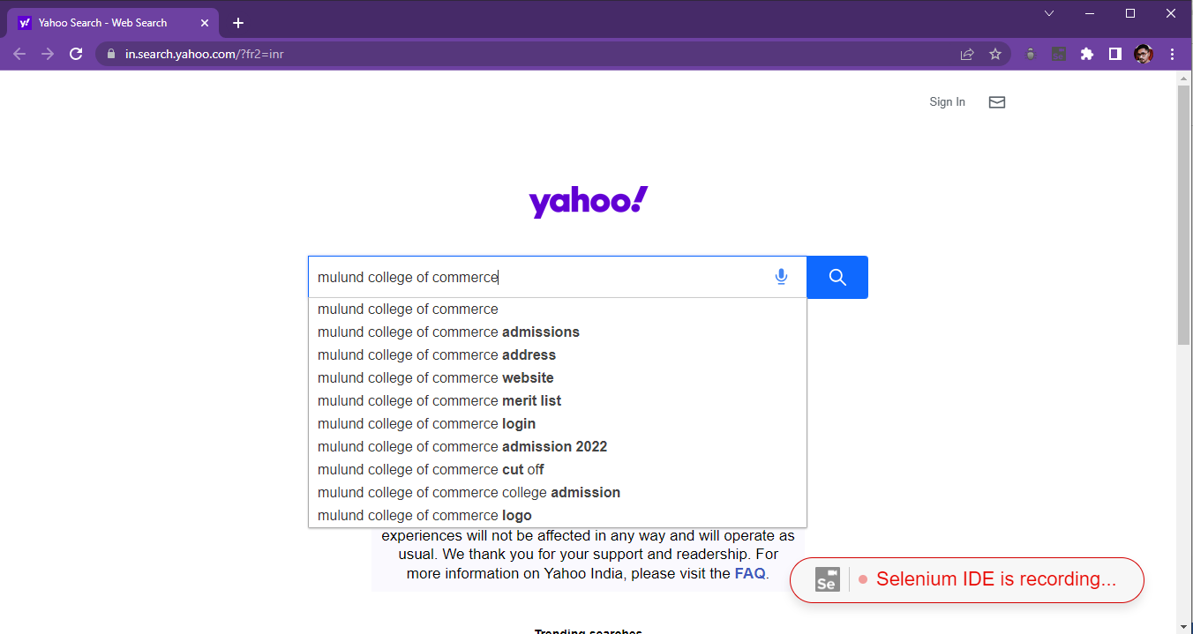

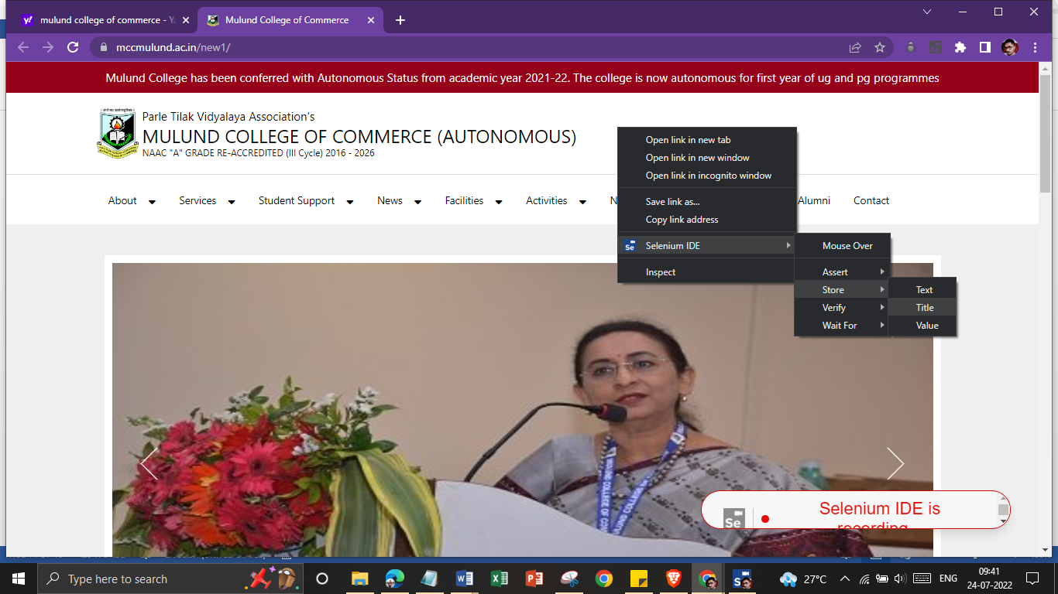

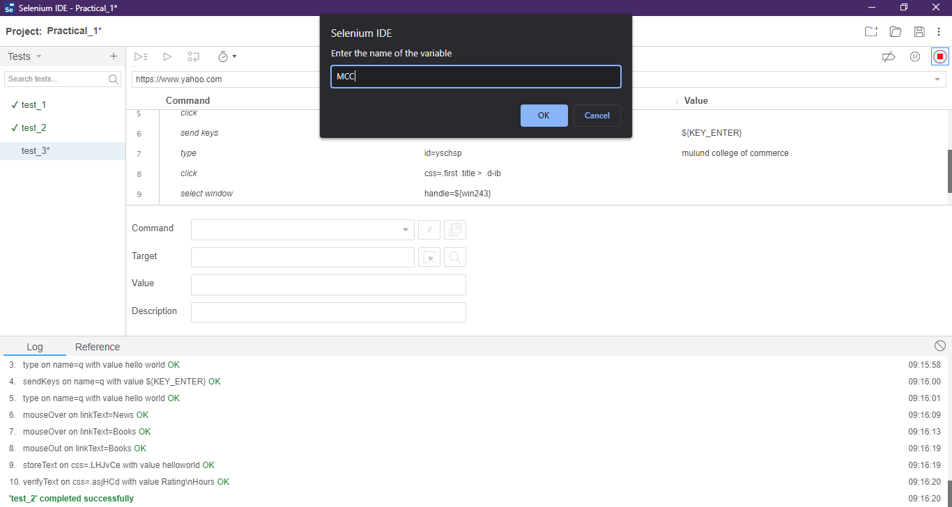

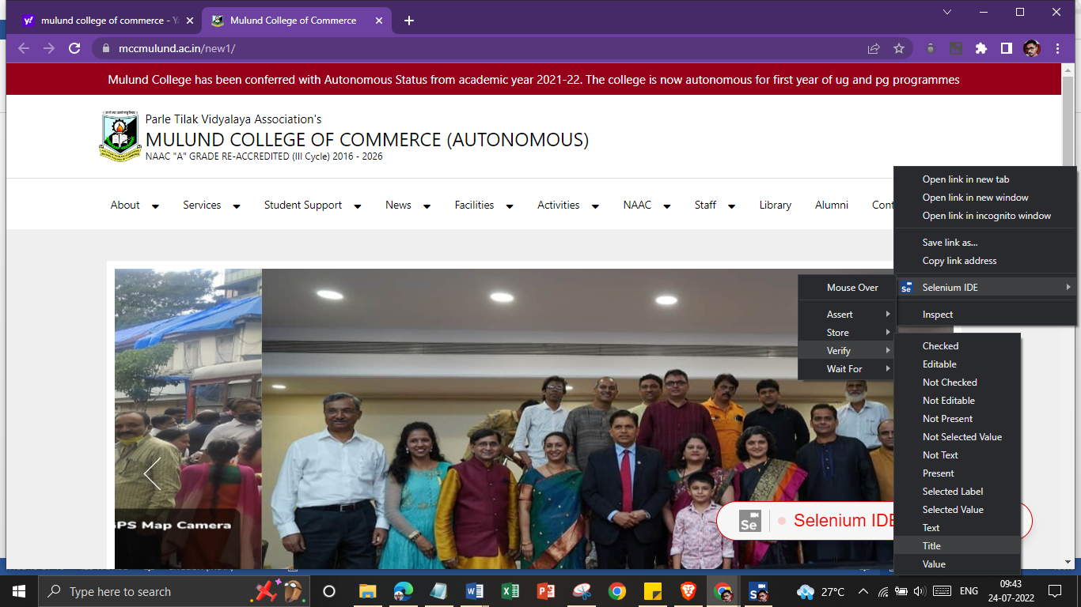

**Step 5:**

Save the Test and Click on “Run Current Test”.

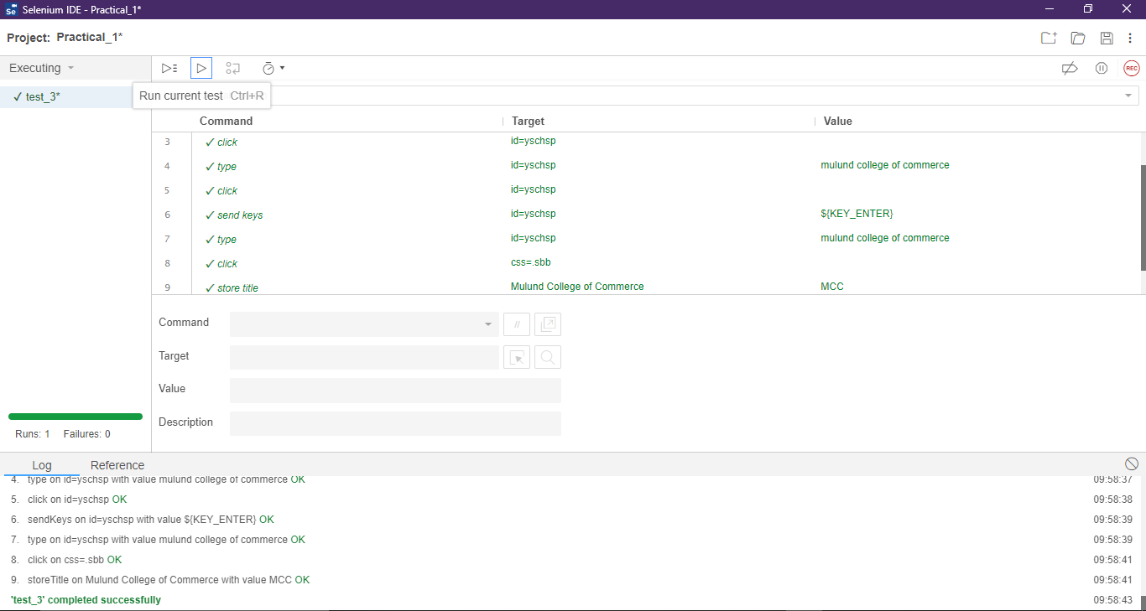

**IV) For** [**https://www.seleniumhq.org**](https://www.seleniumhq.org)**:**

**Step 1:**

Click on “+” icon to add a new test case and name it as follows:

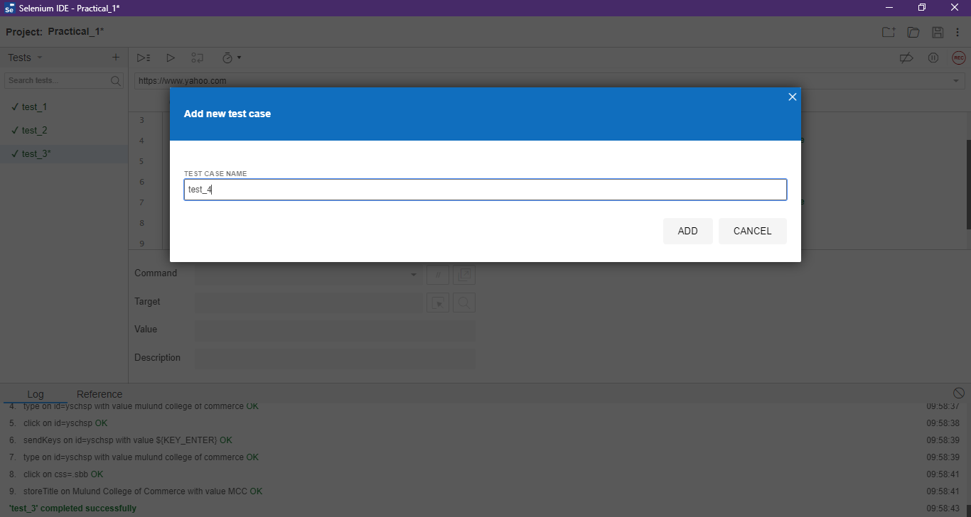

**Step 2:**

Enter the base URL https://www.seleniumhq.org and click on Record Button.

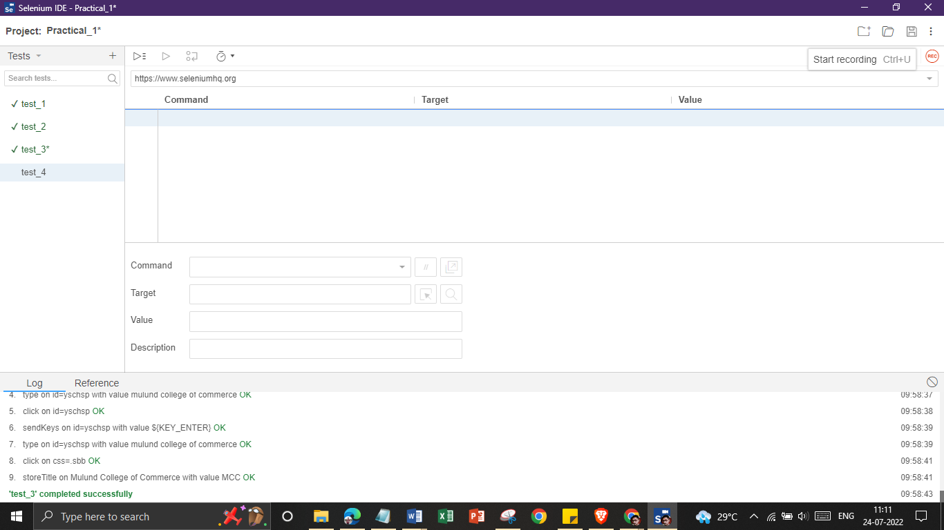

**Step 3:**

Chrome will open the Selenium Page as follows:

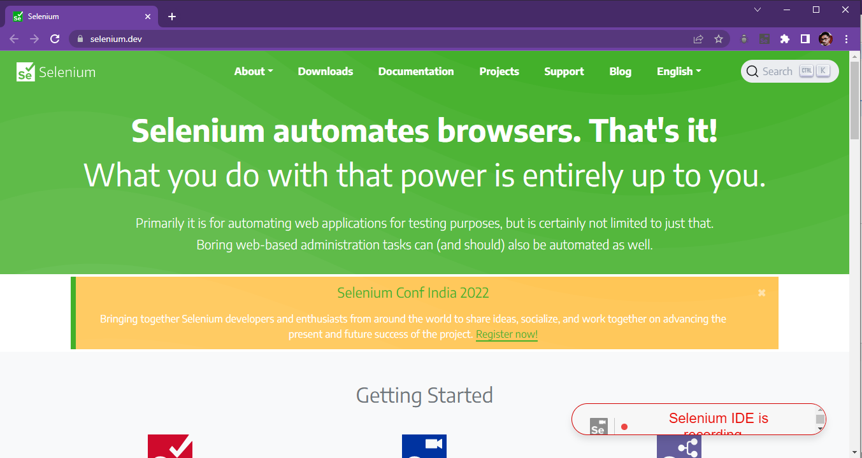

**Step 4:**

Perform The Following Steps:

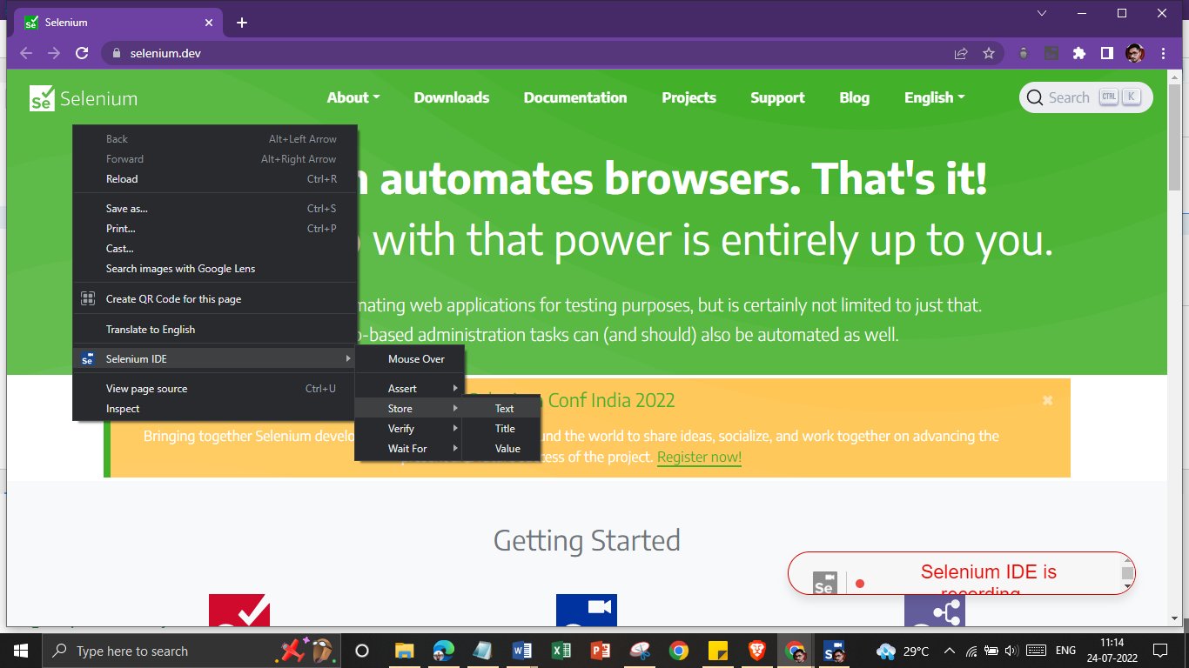

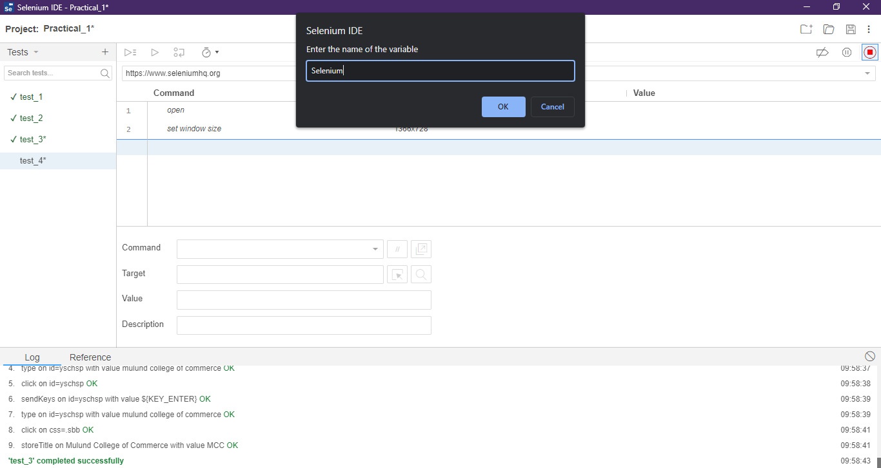

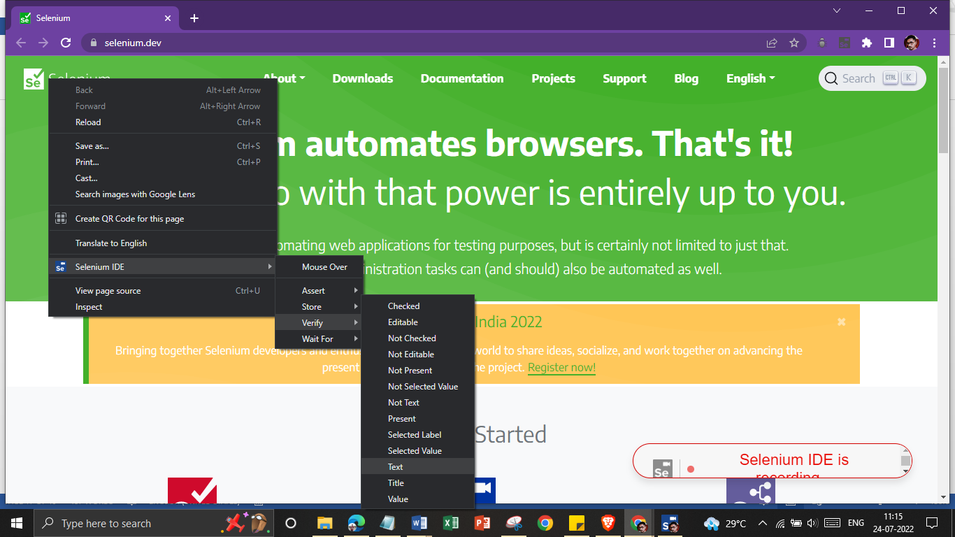

**Step 5:**

Save the Test and Click on “Run Current Test”.

